Lab 6

- UNION

SELECT emp_name FROM employee
UNION
SELECT emp_name FROM employee_1;

Output:

emp_name
Alice Cordoza
John Cretchakov
Anne McDonald
Mary Chen

- UNION ALL

SELECT emp_name FROM employee
UNION ALL
SELECT emp_name FROM employee_1;

Output:

emp_name
Alice Cordoza
John Cretchakov
Anne McDonald
Mary Chen
John Cretckehacho

- INTERSECT

SELECT emp_name FROM employee
INTERSECT
SELECT emp_name FROM employee_1;

Output:

emp_name
John Cretchakov

- MINUS

SELECT emp_name FROM employee
MINUS
SELECT emp_name FROM employee_1;

Output:

emp_name
Alice Cordoza
Anne McDonald

- ROOMS (Grosvenor)

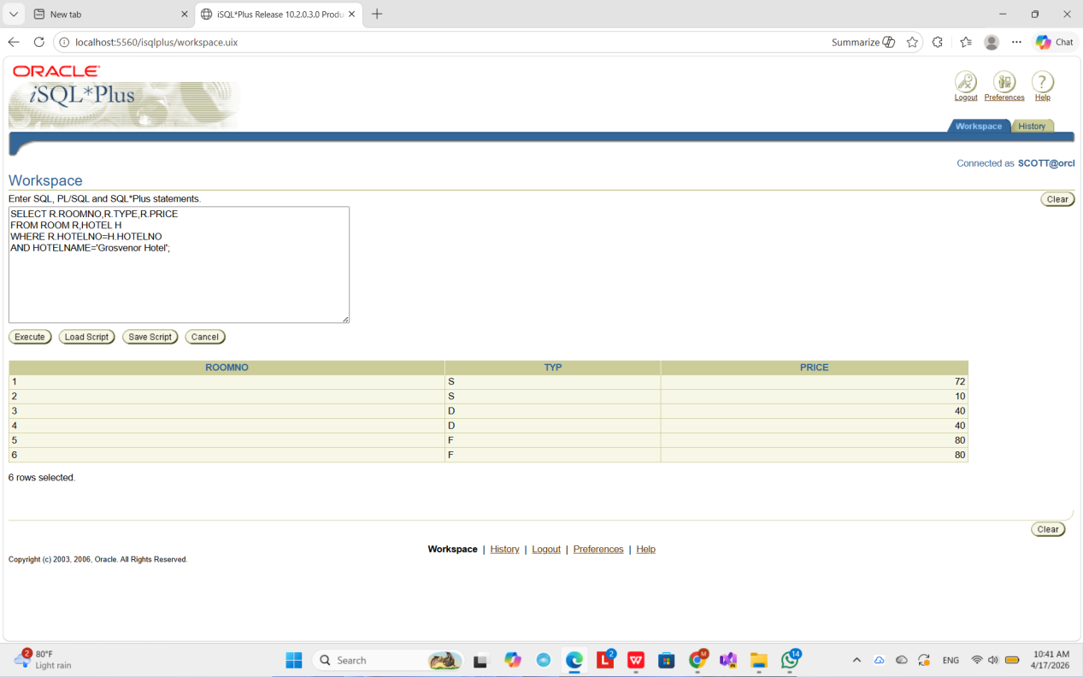

6. HOTEL

